SCSC Student Dress Code
Participants in the SCSC program are REQUIRED to adhere to a conservative dress code. REMEMBER- You are a representative of the Lord Jesus Christ – AS an SCSC student, you are to let His Light Shine, and not distract others from His Message with your physical appearance.
If Jesus and your Grandmother would not think it was modest,…… Don’t Pack It!
As you pack, plan to be modestly covered from neck to knees, both front and back.
Dress Code Basics:
#4 Regarding Length:

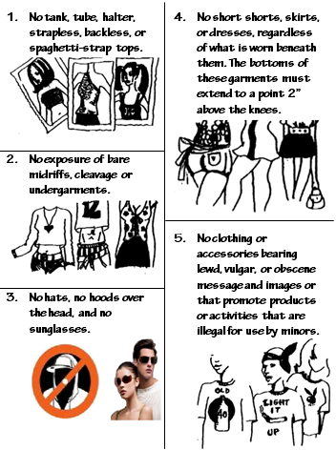
#1 Straps
must be
two inches
wide.

#2 Check
when you
sit.
Wear a
belt as
needed.
No chests
exposed.

#3 Regarding
Inside
Buildings:

#7 No revealing tight clothing
#6 Swimwear must be one piece and modest.
No see through portions.

“What to Pack/Bring” for SCSC On-site Training and Project

Luggage: Pack in the smallest suitcase possible!
Limit to a maximum of 3 pieces • one small suitcase • one carry-on • one additional small item i.e. a purse

Clothing: *Please see the dress code on the reverse side of this page.*
- Day to day clothing (enough for 10 days with no laundry facilities)
- Bring clothing for on-site training which is at a camp
- Ask your PD about items to bring for your specific project activities/events
- Footwear: tennis shoes, dress shoes, optional open toed i.e. flip flops, sandals
- 2 nice outfits (church appropriate)
Lay your clothing out on your bed. Choose *modest items* you want to bring and wear. Then take half of it and put it back in your closet. Pack the rest.
- Swimsuit (must be modest/one piece coverage)
- Jacket – (you may encounter rain)
- Vets please bring SCSC shirt(s)

Bedding is not needed. Sheets, a big towel, a wash cloth, a pillow and case will be provided for you at on-site Training and Evaluation. You can continue to use the same linens and pillow at General Conference. Your host church will provide linens and a pillow for you while on Project.

Training Materials:
- Bible
- Any training materials you received (books, articles, etc)
- Vets please bring SCSC binder
- Notebook, pencil, pens, etc
- Laptops and net books may be helpful but are not required. Songs and games are provided on CD’s.

Other/ Optional:
- Any prescriptions or OTC medications that you require
- Musical instruments
- Camera
- Towel/toiletries/personal items
- Remember, for airline travel carry-on luggage, all liquids must be in 3 oz. containers or less and all collected in a see through quart bag
- Insect repellant
- Sun Screen & Hat

Do NOT bring:
- Large bulky suitcases or bags
- Stuffed animals or toys
- Distracting electronics such as I-pods and hand held games
- Weapons or sharp instruments of any kind
- Tobacco, alcohol or any other illegal drugs
- Extraneous items you DO NOT need at training or on project

