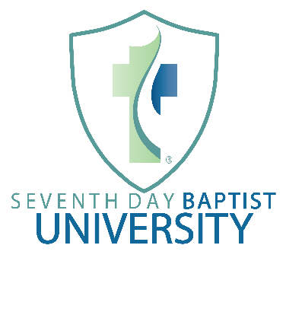
Advanced Pastoral Leadership Certificate:
Program Summary: The purpose of the pastoral leadership certificate is to train called pastors serving in local Seventh Day Baptist churches.
Program prerequisites: Students applying for this program should be recommended by their local churches for admission to the program, as well as serving in a called pastoral role in their local congregation. In addition, students should (1) have completed with the Pastoral Leadership Certificate or (2) admitted to this certificate program based on transfer credit granted by the School of Ministry and the Dean or (3) receive specific permission from the Dean and School of Ministry to take specific classes in this certificate program.
Courses Required:
Course Number Course Title Expected Time Investment
SDBU 310* Advanced Hermeneutics (Greek/Hebrew) 13-15 weeks
prerequisites: SDBU 210, 211, 220, 230, 250
SDBU 311* Advanced Homiletics (Old & New Testament) 13-15 weeks
prerequisites: SDBU 210, 211, 220, 230, 250
SDBU 341 Seventh Day Baptist History 13-15 weeks + seminar
prerequisites: none
SDBU 351* Systematic Theology I: God & Scripture 13-15 weeks
prerequisites: SDBU 250
SDBU 352* Systematic Theology II: Man, Sin & Salvation 13-15 weeks
prerequisites: SDBU 250, 351
SDBU 353* Systematic Theo. III: The Church & Last Things 13-15 weeks
prerequisites: SDBU 250, 351, 352
SDBU 354 SDB Sabbath Theology 13-15 weeks + seminar
recommended: 250, 351, 352, 353
SDBU 371 SDB Applied Ecclesiology 13-15 weeks + seminar
recommended: 250, 351, 352, 353
*denotes courses with one or more prerequisites.
Elective Courses (2 required):
Course Number Course Title Expected Time Investment
SDBU 312-9* Advanced Greek/Hebrew Tools 13-15 weeks
SDBU 320-9* Old Testament Studies 13-15 weeks
SDBU 330-9* New Testament Studies 13-15 weeks
SDBU 340 Church History 13-15 weeks
SDBU 361* Advanced Evangelism 13-15 weeks
SDBU 362* Advanced Apologetics 13-15 weeks
SDBU 363* Worldview and Comparative Religion 13-15 weeks
SDBU 364* Fringe Religious Movements & Cults 13-15 weeks
SDBU 372* Issues in Contemporary Worship 13-15 weeks
SDBU 381* Issues and Competency in Counseling 13-15 weeks
SDBU 382* Issues and Competency in Chaplaincy 13-15 weeks
SDBU 383* Special Needs and Ministry in the Church 13-15 weeks

