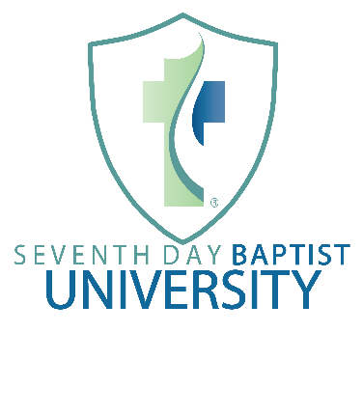
Pastoral Leadership Certificate:
Program Summary: The purpose of the pastoral leadership certificate is to train leaders in local Seventh Day Baptist churches who are already performing or feel called to perform pastoral functions, regardless of whether they are officially carrying the title “pastor” at present.
Program prerequisites: Students applying for this program should be recommended by their local churches for admission to the program, with the local church prepared to take responsibility for providing the students with the opportunity to serve and exercise their gifts under the guidance of church leadership. Students applying for the program should be at least 22 years of age.
Courses Required:
Course Number Course Title Expected Time Investment
SDBU 201 Pastoral Leadership in the Church 6-8 weeks
prerequisites: none
SDBU 210 Bible Interpretation (English Bible) 15-18 weeks
prerequisites: none
SDBU 211* Biblical Preaching 15 weeks
prerequisites: SDBU 210
SDBU 220 Old Testament Survey 13-15 weeks
prerequisites: none
SDBU 230 New Testament Survey 13-15 weeks
prerequisites: none
SDBU 250* Intro to Theology 13-15 weeks
prerequisites: SDBU 210, 220, 230
SDBU 260 Intro to Evangelism & Apologetics 13-15 weeks
prerequisites: none
SDBU 280 Practical Ministry Skills 8-10 weeks
prerequisites: none
SDBU 281 Church Administration & Time Management 6-8 weeks
prerequisites: none
*denotes courses with one or more prerequisites.
Suggested Course Sequence (2 years):
Year One Fall:
SDBU 201 Pastoral Leadership in the Church taken concurrently with
SDBU 281 Church Administration & Time Management taken concurrently with
SDBU 210 Bible Interpretation (English Bible)

Year One Winter/Spring:
SDBU 211* Biblical Preaching taken concurrently with
SDBU 280 Practical Ministry Skills

Year Two Fall:
SDBU 220 Old Testament Survey taken concurrently with
SDBU 230 New Testament Survey

Year Two Winter/Spring:
SDBU 250* Intro to Theology taken concurrently with
SDBU 260 Intro to Evangelism & Apologetics

